Homework Assignment 4

Tyler Paulley

10/9/2016

Problem 1:

**1. Write pseudocode of the greedy algorithm for the change-making problem,**

**with an amount *n* and coin denominations *d*1*>d*2*> . . .>dm* as its input. What**

**is the time efficiency class of your algorithm?**

m is the amount of coin denominations

n is the amount of money to be given as change

for i = 1 to m

change[i] = n / Denominations[i] (rounded down)

n = n mod Denominations[i]

if n = 0 return change[]

else return “cannot give exact change”

The efficiency of the problem is O(m) since that is number loops done in the for loop.

Problem 2:

**1. Apply Kruskal’s algorithm to find a minimum spanning tree of the following**

**graphs.**

a) **bc: 1** | **de: 2** | **bd: 3** | cd: 4 | **ab: 5** | ad: 6 | ce: 6

1

c

b

5

3

d

e

a

2

b) **de: 1** | **cd: 2** | **ef: 2** | **be: 3** | **ab: 3** | **gh: 3** | **ij: 3** | **cg: 4** | **ei: 4**| ad: 4 | ac: 5 | dh: 5 | **il: 5** |

**gk: 6**

3

b

aa

3

1

2

2

c

f

e

d

4

3

4

3

i

j

h

g

5

6

k

l

Problem 3:

**2. Solve the following instances of the single-source shortest-paths problem with**

**vertex *a* as the source:**

a) d(a, 7) 🡪 b(d, 9) 🡪 c(d, 12) 🡪 e(c, 18)

b) b(a,3) 🡪 d(a,4) 🡪 c(a,5) 🡪 e(d,5) 🡪 f(e,7) 🡪 h(d,9) 🡪 g(c,9) 🡪 i(e,9) 🡪 j(f,12) 🡪 l(i,14) 🡪 k(g,15)

Problem 4:

**4. Let *T* be a tree constructed by Dijkstra’s algorithm in the process of solving**

**the single-source shortest-paths problem for a weighted connected graph *G*.**

**a. True or false: *T* is a spanning tree of *G*?** True

**b. True or false: *T* is a minimum spanning tree of *G*?** False, the shortest path will not always result in a minimum spanning tree.

Problem 5:

**2. For data transmission purposes, it is often desirable to have a code with a**

**minimum variance of the codeword lengths (among codes of the same average**

**length). Compute the average and variance of the codeword length in two Huffman codes that result from a different tie breaking during a Huffman**

**code construction for the following data:**

**symbol A B C D E**

100a

**probability 0.1 0.1 0.2 0.2 0.4**

1

0

.4 x 1 + .2 x 2 + .2 x 3 + .1 x 4 + .1 x 4 = 2.2

.6

.44

2.2 is the average length in bits

1

0

e

.2

.4

1

0

c

(4 - 2.2)^2 x 0.1 x 2

+ (3 - 2.2)^2 x 0.2

.2

.2

+ (2 - 2.2)^ 2 x 0.2

1

0

d

+ (1 - 2.2)^2 x 0.4 = 1.36

.1

.1

1.36 is the variance

4

c

Problem 6:

**5. a. Write pseudocode of the Huffman-tree construction algorithm.**

**b. What is the time efficiency class of the algorithm for constructing a Huffman tree as a function of the alphabet size?**

a)

while size of Queue is > 1

Tree Left = the smallest weight in the Queue

Delete the smallest weight from the queue

Tree Right = smallest weight in the queue

Delete the smallest weight

Create a tree with Tree Left and Tree Right as subtrees, the weight of the tree is equal to their sum

Insert the tree into the Queue

return the Tree

b)

The majority of the running time will be used in the deletions from the Queue. The efficiency will be O(n log n) by using min-heaps.

**Examples of the change-making code:**

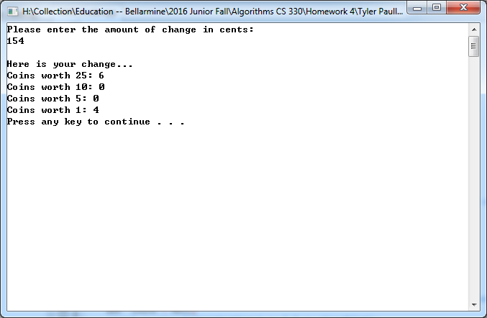

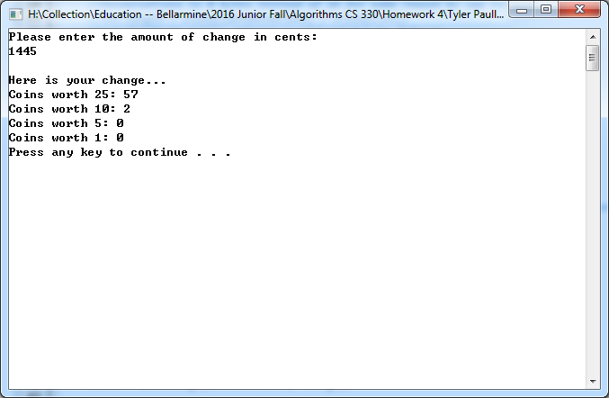

**Examples of the closest coordinate pair code:**

